Week Two Activity 4 and 5:

CSIS 3600

Alexander Cannell

**Add aliases to launch firefox and matlab.**

alias firefox='/cygdrive/c/"Program Files (x86)/Mozilla Firefox/firefox.exe"'

alias notepad++='/cygdrive/f/"Notepad++Portable/Notepad++Portable.exe"'

alias matlab='/cygdrive/g/"Student/Math/MATLAB/R2009b/bin/matlab.exe"'

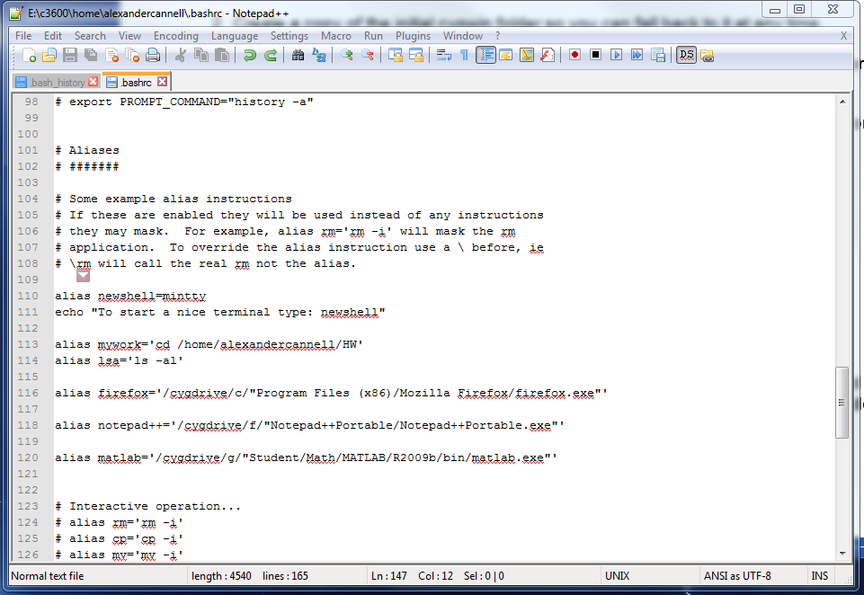

**Add firefox and matlab to your PATH variable and test it.**

export PATH='/cygdrive/c/Program Files (x86)/Mozilla Firefox':$PATH

export PATH='/cygdrive/g/Student/Math/MATLAB/R2009b/bin':$PATH

